APEX Interim Report (6/99) Section 3:

Chemical Compatibility Issues
The focus of this section is on the chemical compatibility issues between structural materials and coolants, with an emphasis on oxidation in Group V and VI refractory alloys. At low temperatures and pressures, the chemical reactions of a gas with a solid generally result in the formation of solid corrosion products. However, at elevated temperatures and low oxygen partial pressure the formation of volatile corrosion products is thermodynamically favored. The chemical compatibility issues are examined based on thermodynamic and non-equilibrium analysis to estimate upper bounds for operating temperatures and oxygen partial pressures in the He-coolant.

3.1 Temperature and Oxygen Partial Pressure Limits for Mo and W Alloys
He-Cooled Concepts, etc.
The approach to model the high-temperature oxidation is to use a quasi-equilibrium treatment of heterogeneous reactions for the systems oxygen-W and oxygen-Mo. The rate-limiting step in these reactions is the trapping (adsorption) of oxygen atoms until equilibrium is reached. Assuming that the helium pressure is P_{sys} and the gas temperature is T*, the oxygen partial pressure (P_{O2})is given by:
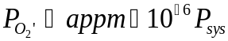 (1)
The adsorption of oxygen depends on the oxygen impingement (Z_{O2}) per unit area of wall surface, given by:
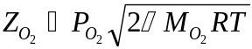 (2)
were M_{O2} is the molar weight of oxygen, R is the universal gas constant and T is in K. For W, the thermodynamic reactions take place based on:
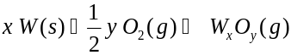 (3)
A similar reaction describes the oxidation of Mo, however, at temperatures between 1500 and 2500K the reaction is more precisely described by:
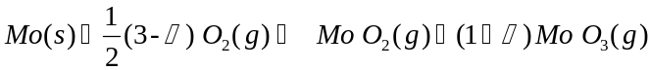 (4)
The formation enthalpies and entropies of the oxides of Mo and W are given in Table 1. The quasi-equilibrium treatment of oxidation is based on the method developed by Batty and Stickney []. The principle parameter in the quasi-equilibrium treatment is the equilibration probability, ζ, which depends on the probability of the impinging molecule s to have sufficient energy to surmount the activation barrier. If ζ_{O2} represents the probability that an impinging molecule will be equilibrated, then the rate of adsorption or equilibration Γ_{O2} is:
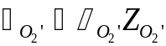 (5)
were Z_{O2} is the impingement rate of O₂ molecules on the surface given by equation (2). Letting i be W_{x}O_{y} and the Gibbs Free energy be:
(6)
the following system of equations can be solved for the partial pressure of oxygen, which results in the equilibration of the impinging oxygen molecules on the wall:
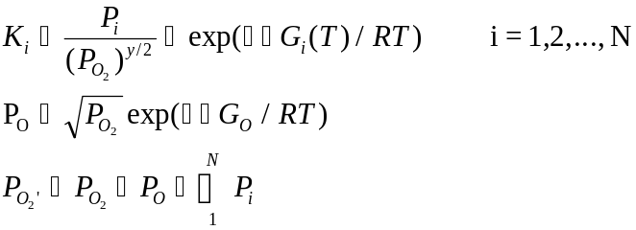 (7)
The equilibration probabilities have been established for W:
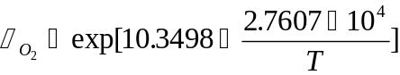 (8)
and for Mo:
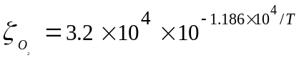 (9)
were T is in K.
Typical evaporation rate measurements W [1] are shown in Fig. 1. The measurements show a distinct maximum for W at around 2200 K. Estimates for the evaporation rate of W and Mo under typical APEX operating conditions (10 MPa helium; 1ppm oxygen) are shown in Fig. 2. Similar to the measurements the W evaporation rate also reaches a maximum value at 2200 K and that of Mo reaches an asymptotic maximum around the same temperature. However, the estimated rate of evaporations are well above any experimental findings. The reason for the higher predicted evaporation rates is that the boundary layer scattering effects of a moving coolant are not reflected in the above model.

BOUNDARY LAYER EFFECT
Under laminar flowing conditions the oxygen impingement rate can be significantly lower compared with a static coolant. The reason is the formation of a boundary layer, which adds resistance for the impinging oxygen. To estimate the effects of the boundary layer the collisional and the boundary layer resistances have to be estimated. The kinetic or collisional impingement rate has to balance the boundary layer diffusion rate. This condition allows the formulation of a “blowing” factor, or the reduction in oxygen impingement rate because of the existence of the laminar boundary. The following set of equations provide the boundary layer resistance (R_{B})term:
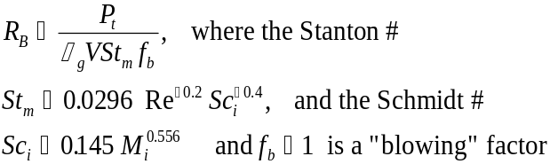 (11)
and the kinetic resistance (R_{k})term is given by:

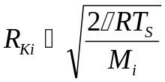 (11)
Using the boundary layer and the collisional resistances the surface recession rate is determined as:
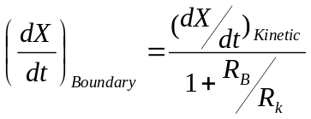 (12)

The results of applying the effects of the boundary resistance to the recession rate of W and Mo is shown in Figures 3 and 4.
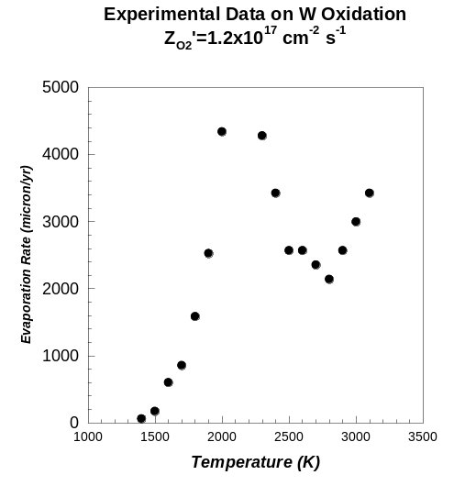
Figure 0: Experimental evaporation rates for W exposed to oxygen partial pressure of 300 torr [1].
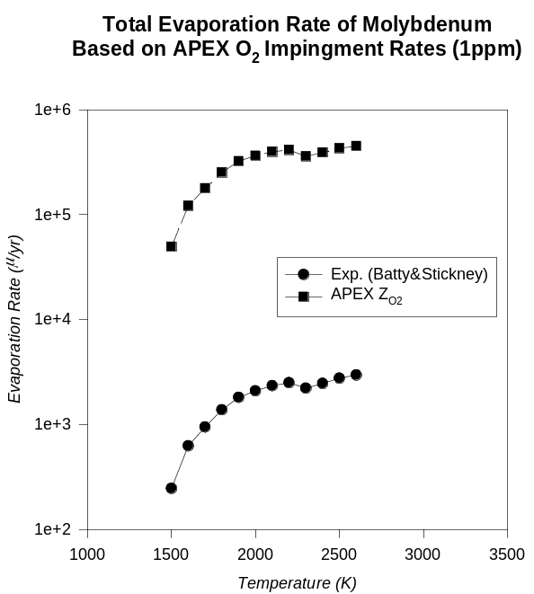
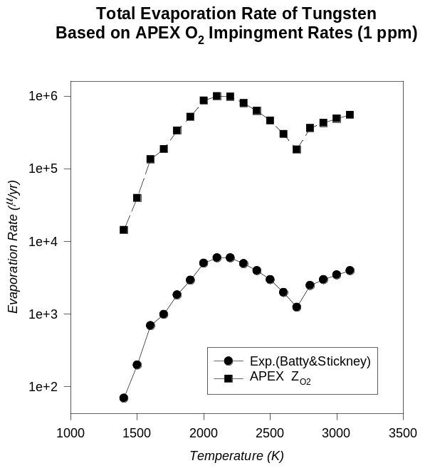
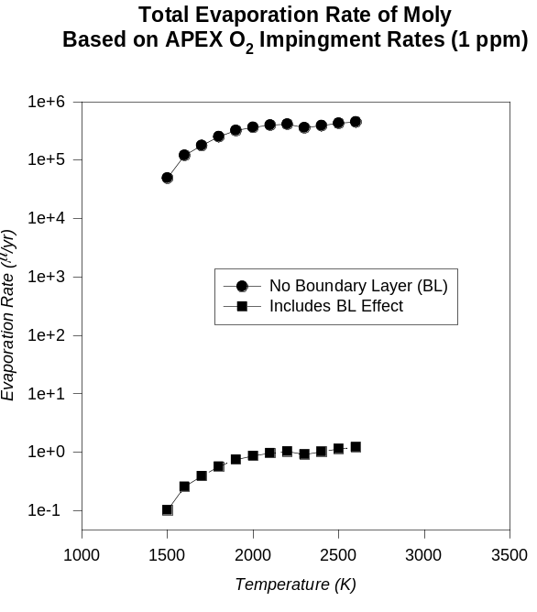
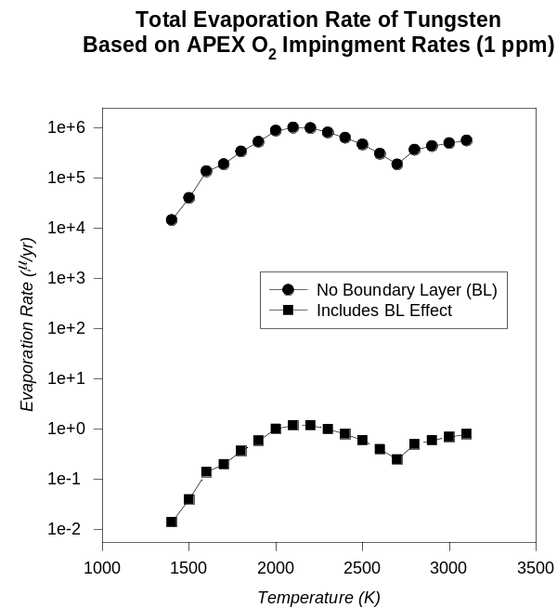
Figure 0: Model prediction of W and Mo evaporation rates based on 10 MPa He-coolant containing 1 ppm oxygen.
Figure 3: Boundary layer effect model of W and Mo evaporation rates based on 10 MPa He-coolant containing 1 ppm oxygen.
Table 1: Enthalpies and Entropies for W and Mo.
Tungsten |  | Molybdenum
Species | ΔHf_{298.15} (kcal/g.mole) | Species | ΔHf_{298.15} (kcal/g.mole) | ΔSf_{298.15} (cal/g.mole.K)
O(g) | 59.559 | O(g) | 61.3 | 16
W O(g) | 101.6 | Mo O(g) | 95 | 25.5
WO₂ (g) | 18.3 | MoO₂ (g) | 11.0 | 9.0
W O₃ (g) | -70.0 | Mo O₃ (g) | -80 | -15.5
W₂ O₆ (g) | -278.2 | Mo₂ O₆ (g) | -270 | -72
W₃O₈ (g) | -408.7 | Mo₃O₈ (g) | -400 | -118
W₃O₉ (g) | -483.6 | Mo₃O₉ (g) | -463 | -132
W₄O₁₂ (g) | -670.2 | Mo₄O₁₂ (g) | -640 | -190

The effect of a boundary layer resistance to the oxygen impingement rate and therefore the probability of forming volatile oxides of W and Mo can result in several orders of magnitude reduction of evaporation rates. The above model does not take into account many of the physical features of a real wall, such as, roughness, bends, temperature variations along the flow. These issues will affect the final evaporation rate, however it is reasonable to assume that the evaporation rate of W and Mo will be below a few microns per year, when operated in a temperature range between 1200 and 1300ºC.

SUMMARY
Formation of volatile oxides can lead to pronounced surface erosion of Group VI metals (Mo, W) at elevated temperatures. The evaporation rate increases rapidly up to ~2000K in both Mo and W. If boundary layer scattering effects are ignored, the evaporation rate exceeds 100 μm/y at ~1500 K in both materials for 1 ppm oxygen in He at a pressure of 10 MPa. Boundary layer effects may reduce the evaporation rate by several orders of magnitude. The calculations suggest that limitations on mass transport through the boundary layer may reduce the erosion rate to less than 10 μm/y at wall temperatures up to 2600 K in both Mo and W.

3.2 Temperature and Oxygen Partial Pressure Limits for V, Nb, and Ta Alloys
All of the Group V metals have a high affinity for oxygen and unrealistically low oxygen partial pressure (< 10⁻²⁰ atm.) would be required to avoid oxygen pickup based on thermodynamics. In practice, kinetic processes (oxygen diffusion and impingement flux) control the oxygen pickup. The diffusion of oxygen at T<600ºC is too slow to be of concern in engineering applications. At T>600ºC, pronounced oxygen pickup will occur unless the oxygen partial pressure is low enough to limit the flux of oxygen striking the metal surface. A rough calculation indicated that oxygen pickup of <1000 wt.ppm can be achieved for long-term (10 yr.) exposures if the oxygen partial pressure is <10⁻⁴ torr. The effects of mass transfer limitation through the boundary layer need to be investigated to determine if higher oxygen partial pressures are acceptable.

3.3 Review of Corrosion Database for Li, Pb-Li, and Sn-Li
Sn-coolant Concepts,
5 micron corrosion limit

The limited experimental database on corrosion of structural materials in Sn was reviewed. This information is relevant for the evaluation of Sn and Li as a potential coolant/breeding material in austenitic and ferretic steels which corrode rapidly in Sn at temperature above ~400ºC. Additional experimental data are needed for other structural materials, although several materials appear to be compatible with Sn at temperatures of interest for APEX. The physical nature of Sn interaction with structural materials needs to be experimentally examined, so as to plan for corrosion control strategies.

J.C. Batty and R. E. Stickney, J. Chem. Phys., Vol. 51, No. 10 (1969) 4475.

